**Springboard Software Engineering**

**Section 29: Capstone Project 1**

**Updated DB schema and functionality**

**API**

The API to be used has been revised, it is found at:

<https://www.api-football.com/>

It will be accessed via the API platform:

<https://rapidapi.com/marketplace>

**Functionality**

The data offered is extensive and, to enable a feasible delivery within the timescale, ambitions will be restrained. The app will be dedicated to the English Premier League and the ongoing season only.

Removed from version 1 of the proposal are the comments functionality, the user-specific news feed and video highlights. Added will be the live match data which are available in much more detail than the first API reviewed. These will be presented in a graphical manner as much as possible for aesthetic purposes and improved user comprehension. It may be possible to add in more features or reintroduce the comments if the work progresses faster than expected.

As a reminder, the planned delivery covers the following:

* Club information
* Fixtures (past and present)
* Team news
* Current scores
* League positions and performance statistics
* Breaking news stories associated with the user’s subjects of interest
* User profile
* Predictions: top four; bottom three; managerial dismissals

**Database schema**

<https://app.genmymodel.com/api/projects/_FbW1UEqTEeu9ts3EO9yYXg/diagrams/_FbW1UkqTEeu9ts3EO9yYXg/svg>

The schema has been updated to reflect the change in functionality to be offered and also the proposal to save some of the API data in the app’s PostgreSQL database; data which changes infrequently and so will avoid needless API calls.

User-focussed tables

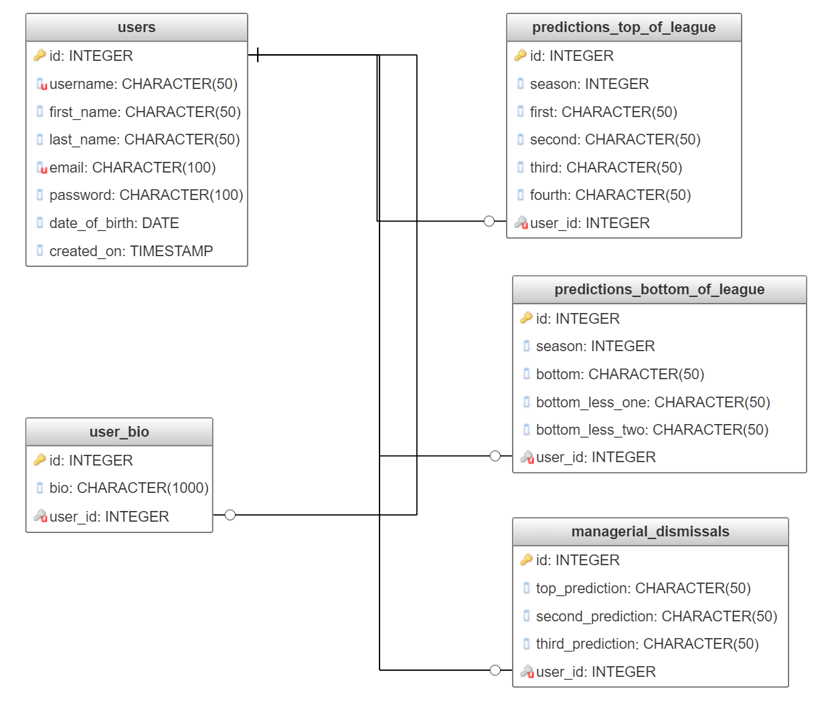

Schema for data that changes infrequently and so will be stored by the app.

Currently, the app is planned to be relevant only to the ongoing season. However, the option to widen this has been provided by introducing the table season_league_id. This takes into account that the league_id changes with each season and also the same league name can occur in more than one country, hence the need for the country column.

